Registration program

er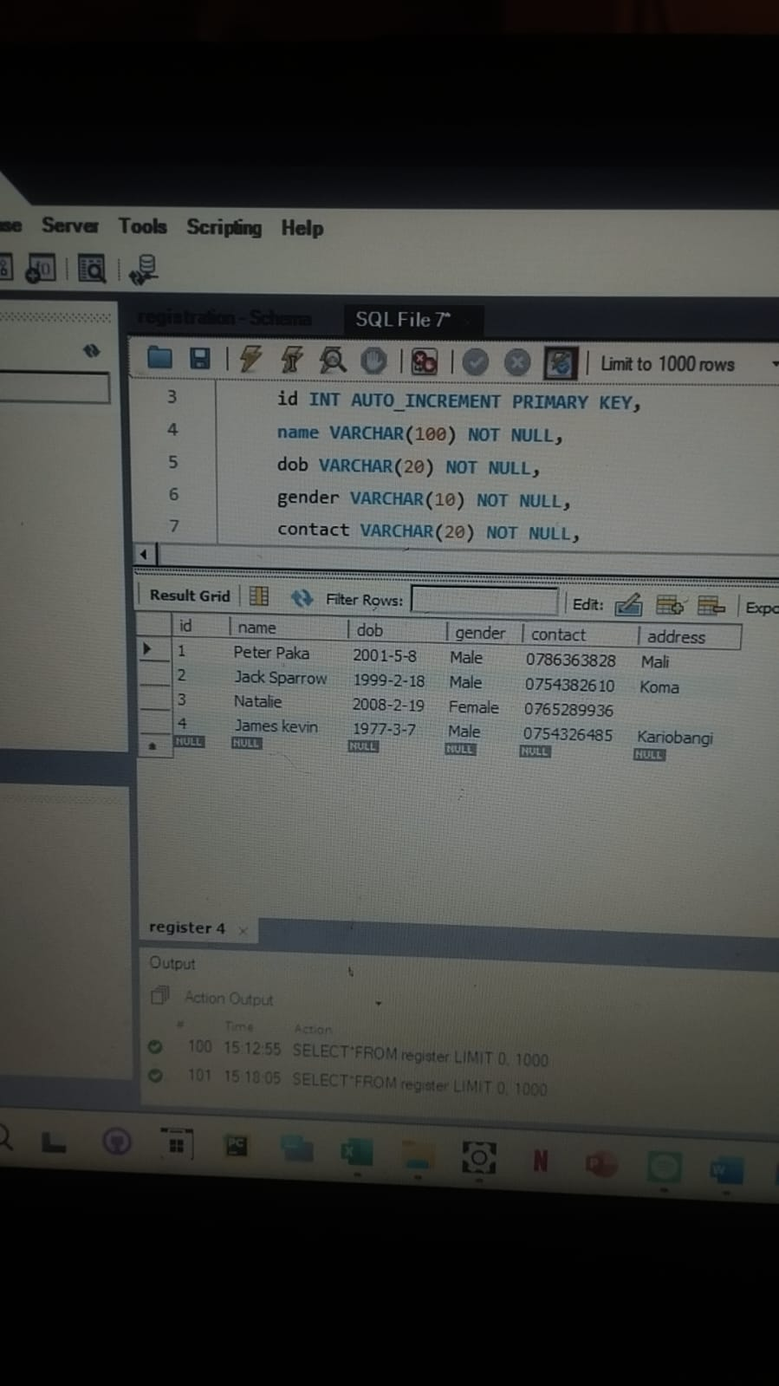

USE registration;

CREATE TABLE register (

id INT AUTO_INCREMENT PRIMARY KEY,

name VARCHAR(100) NOT NULL,

dob VARCHAR(20) NOT NULL,

gender VARCHAR(10) NOT NULL,

contact VARCHAR(20) NOT NULL,

address VARCHAR(200) NOT NULL

);

DESCRIBE register;

SELECT*FROM register